**VS2015 C++ ICE 3.7**

# 地址

<https://zeroc.com/>

<https://doc.zeroc.com/display/Ice36/Using+the+Windows+Binary+Distribution>

<https://doc.zeroc.com/display/Ice36/Writing+an+Ice+Application+with+Java>

<https://doc.zeroc.com/display/Ice36/Writing+a+Slice+Definition>

<https://zeroc.com/distributions/ice>

# 配置环境变量

C:\Program Files\ZeroC\Ice-3.7.0\bin 添加至path

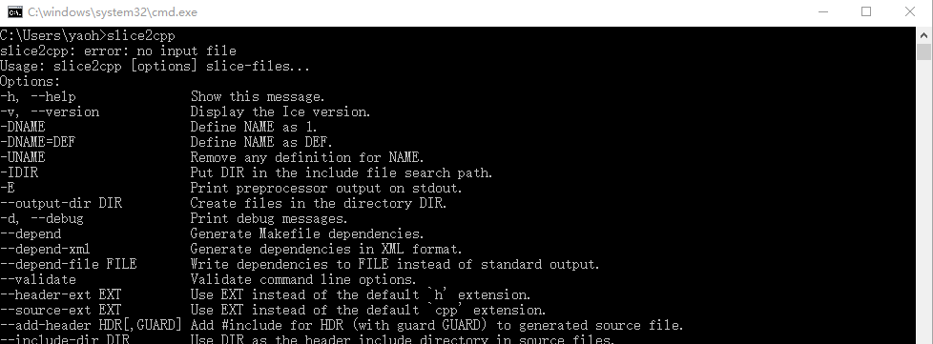

# 开始你的程序

## 定义ice文件

<https://doc.zeroc.com/display/Ice35/Writing+a+Slice+Definition>

module demo {

interface Printer {

void printString(string s);

};

};

命名最好与接口名相同，如Printer.ice。注意为了区分，我这Demo改成了小写，与官方示例略有区别

## 生成不同语言的代码

slice2java Printer.ice

slice2cpp Printer.ice

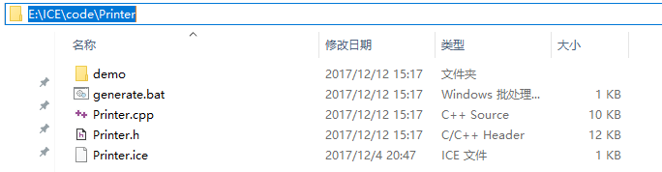

注意工作目录是：E:\ICE\code\Printer

## c++ server实现

### 新建c++控制台项目rtdbICE

将Printer.cpp复制到c++工程目录，然后添加现有项

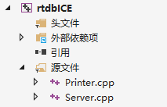

### 头文件依赖

E:\ICE\code\Printer

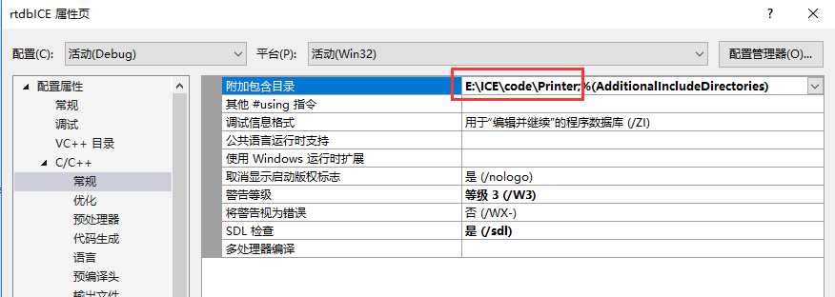

### 新增cpp文件

<https://doc.zeroc.com/pages/viewpage.action?pageId=18255202#WritinganIceApplicationwithC++(C++11)-WritingandCompilingaServerinC>++

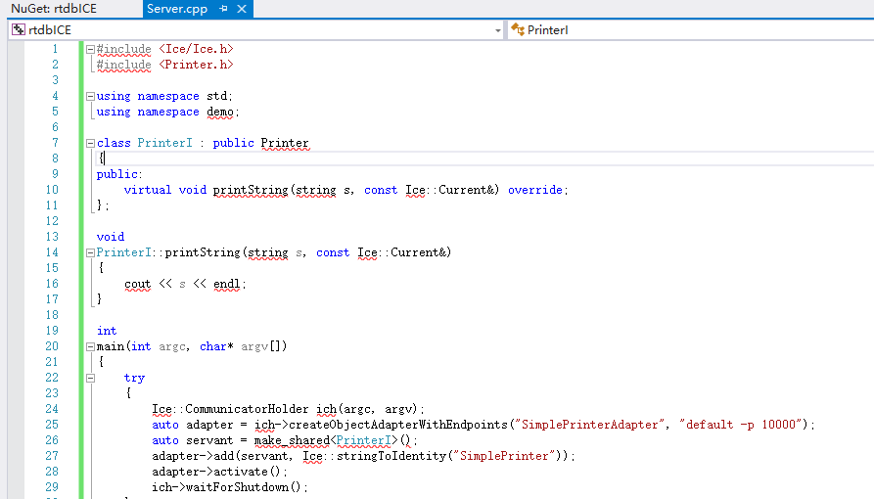

### 加载依赖

下载

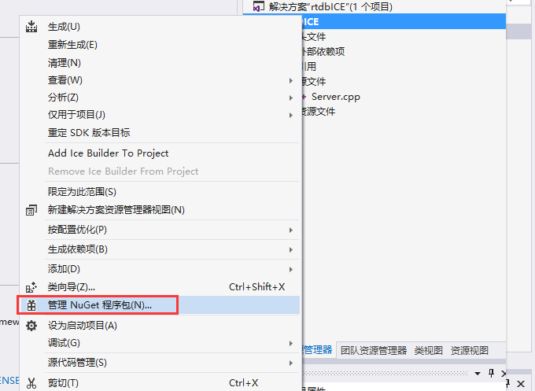

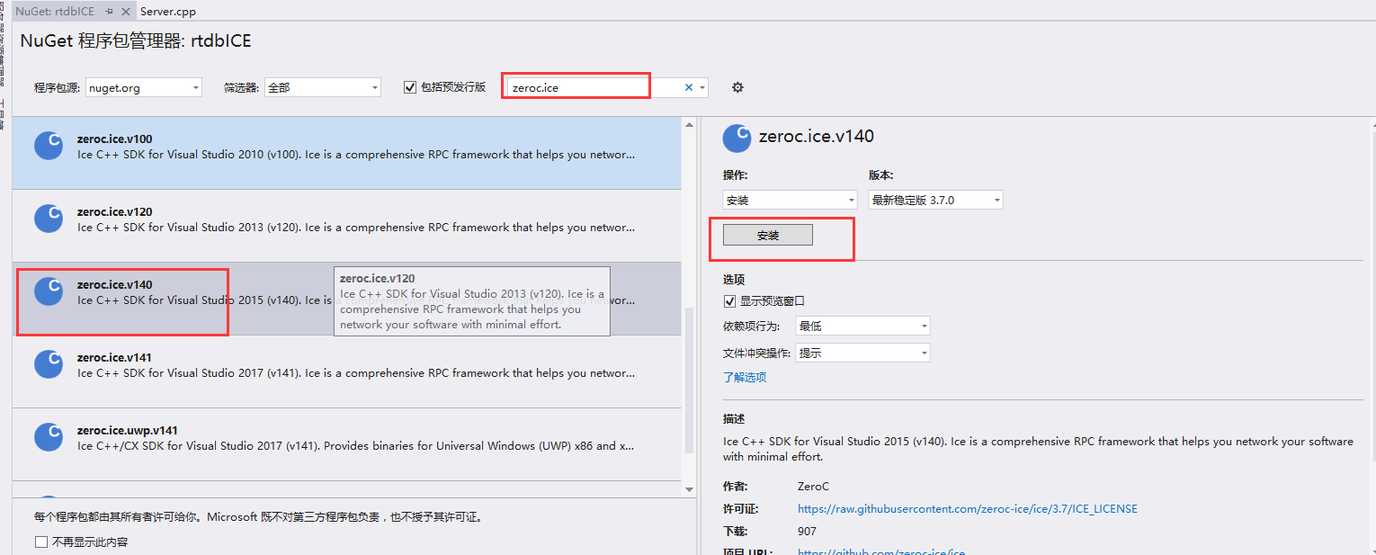

# java client实现

### 下载jar包

http://central.maven.org/maven2/com/zeroc/ice/3.7.0/ice-3.7.0.jar

### 复制java代码至项目src下

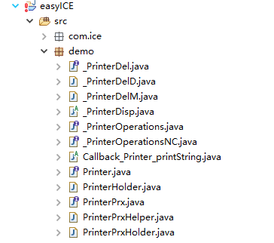

### 创建Client类

**public** **class** Client {

**public** **static** **void** main(String[] args) {

**int** status = 0;

Ice.Communicator ic = **null**;

**try** {

ic = Ice.Util.*initialize*(args);

Ice.ObjectPrx base = ic.stringToProxy("SimplePrinter:default -h 127.0.0.1 -p 10000");

PrinterPrx printer = PrinterPrxHelper.*checkedCast*(base);

**if** (printer == **null**){

**throw** **new** Error("Invalid proxy");

}

printer.printString("Hello World!");

} **catch** (Ice.LocalException e) {

e.printStackTrace();

status = 1;

} **catch** (Exception e) {

System.***err***.println(e.getMessage());

status = 1;

} **finally** {

**if** (ic != **null**)

ic.destroy();

}

System.*exit*(status);

}

}

运行

# 测试

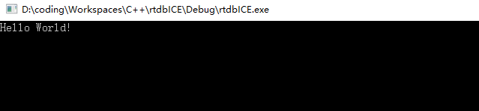

# 问题解决

笔者当前解决方案是Debug模式，所以启动时缺少ice37d.dll、bzip2d.dll文件，从…\rtdbICE\packages\zeroc.ice.v140.3.7.0\build\native\bin\Win32\Debug